ShopEZ Hub: One-Stop Shop for Online Purchases
Project Documentation

- Introduction
Project Title: ShopEZ Hub: One-Stop Shop for Online Purchases

Team Members:
Team member : Mosa Praveen

2.Project Overview
Purpose:
ShopEZ Hub is a full-stack web-based e-commerce platform developed using modern technologies including React.js, Node.js, Express.js, PostgreSQL, and Drizzle ORM.
The primary goal is to provide users with a secure and efficient platform to browse products, manage carts, place orders, and track order history while enabling administrators to manage products and orders through a structured backend system.

3.Features:
The ShopEZ Hub platform includes the following key features:
User Authentication:
- Secure user registration and login
- Password encryption
- Session management
Product Browsing:
- Dynamic product listing
- Product search functionality
- Category-based filtering
Cart Management:
- Add products to cart
- Remove products from cart
- View cart summary
Order Management:
- Place orders
- View order history
- Cancel orders
Admin Dashboard:
- Add new products
- Update product details
- Delete products
- Monitor user orders
3. Architecture
The ShopEZ Hub application follows a 3-tier architecture, separating frontend, backend, and database layers.
User Interface Layer (React.js)
Handles user interaction including:
- Login / Register
- Product browsing
- Cart operations
- Order management
Application Layer (Node.js & Express.js)
- Processes API requests
- Manages authentication
- Handles business logic
- Connects to database
Data Layer (PostgreSQL)
- Stores Users, Products, Orders
- Managed using Drizzle ORM

Architectural Diagram:
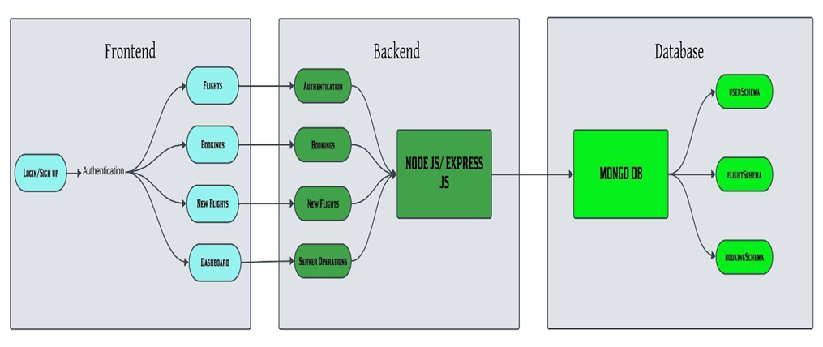
4. Setup Instructions
Prerequisites:
- Node.js:Node.js (v16 or higher) must be installed to run the backend server.
- npm: Node Package Manager (comes with Node.js) to install project dependencies
- MongoDB: MongoDB (Local or MongoDB Atlas) for storing user, flight, and booking data.
- React.js: For building the frontend user interface.
- Express.js: For handling backend routing and API development.
- Mongoose: For connecting Node.js with MongoDB and performing CRUD operations.
- bcrypt: For secure password encryption.
- Code Editor: Visual Studio Code or any preferred IDE.
- Git: For Version Control
Installation:
- Clone the Repository:git clone <your-repository-link>
- Navigate to Project Directory:cd Flight-Booking-app
- Backend Setup:
- Navigate to server folder:cd server
- Set Up Environment Variables (.env file):
Create a file named .env inside the server folder.
o Add the following lines to your .env file, replacing the placeholder with your actual MongoDB connection string:
- MONGO_URI="YOUR_MONGODB_CONNECTION_STRING"
- PORT=6001
- Start the Backend Server: npm start
- Frontend Setup:
- Navigate to client folder:cd client
- Start the React Application:npm start
  - Ensure there are no spaces around the = sign and values are in double quotes. This securely manages your API credentials.
5. Folder Structure
ShopEZ-Hub/
│
├── client/ → React frontend (Vite)
├── server/ → Node.js + Express backend
├── shared/ → Shared types and utilities
├── script/ → Additional scripts
│
├── drizzle.config.ts
├── tailwind.config.ts
├── vite.config.ts
├── tsconfig.json
├── package.json
└── .replit
Running the Application
To run the ShopEZ-Hub application locally:
- Open your terminal or command prompt.
- Navigate to the project's root directory ShopEZ-Hub: D:\Mernstack/ ShopEZ-Hub >
- Backend runs on:http://localhost:6001
- Frontend runs on:http://localhost:3000
6. API Documentation
Authentication APIs:
- POST /api/register
- POST /api/login
Product APIs:
- GET /api/products
- POST /api/products (Admin)
- PUT /api/products/:id (Admin)
- DELETE /api/products/:id (Admin)
Order APIs:
- POST /api/orders
- GET /api/orders/:userId
- DELETE /api/orders/:id
7. Authentication
Authentication is implemented using:
- Password encryption
- Session management
- Role-based access (User/Admin)
- Protected routes for admin operations
Passwords are encrypted before storing in the database.
8. User Interface
The UI is built using React.js and Tailwind CSS with responsive design.
Main Application Layout:
- Navigation bar
- Login/Register pages
- Product listing page
- Cart page
- Order history page
- Admin dashboard
Dynamic Data Handling:
- Axios / Fetch API for backend communication
- Real-time product display
- Order confirmation updates
9. Testing
Functional Testing:
- User login validation
- Product search accuracy
- Cart operations testing
- Order storage verification
- Admin CRUD operations
Integration Testing:
- Frontend-backend API communication
- Database updates after placing order
Error Handling:
- Invalid login credentials
- Missing input validation
- Database connection errors

10.Screenshots:

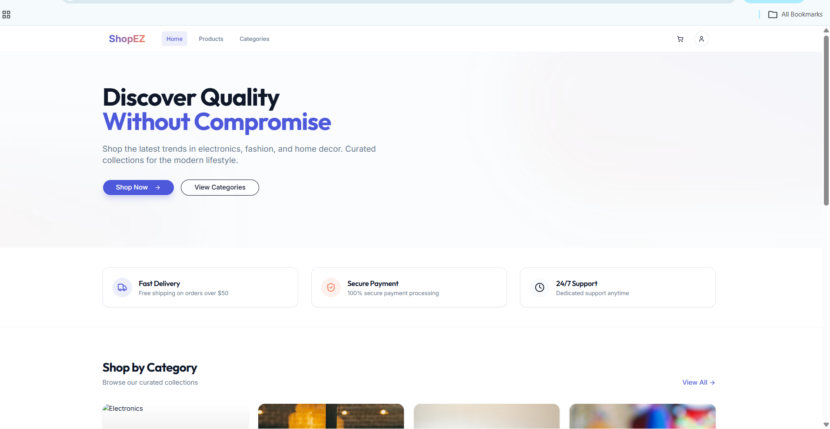
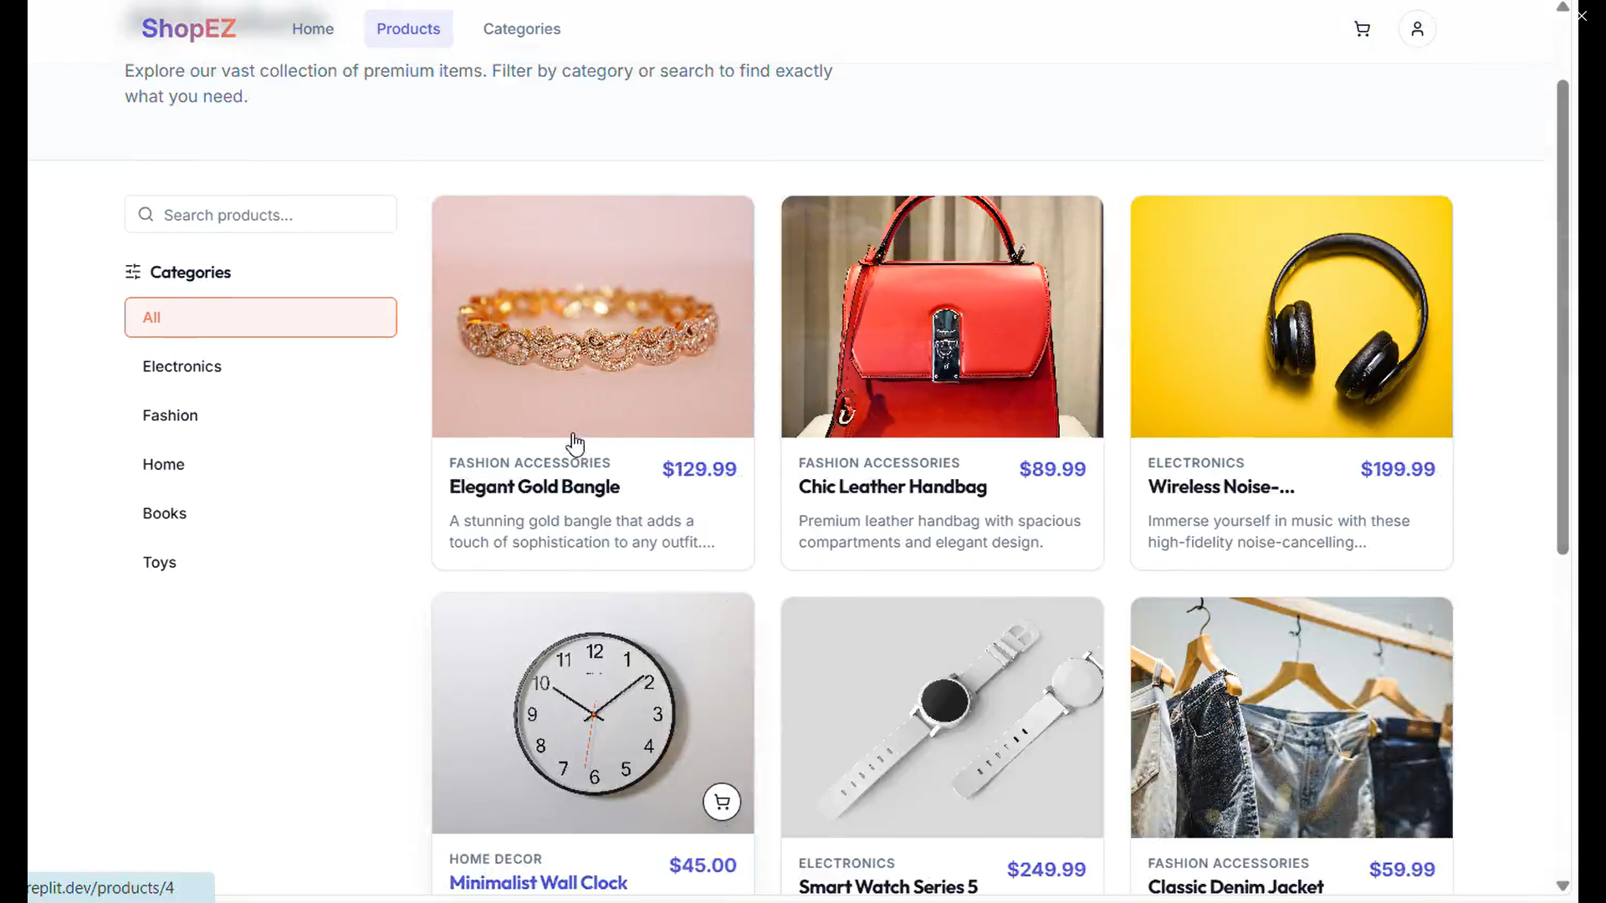
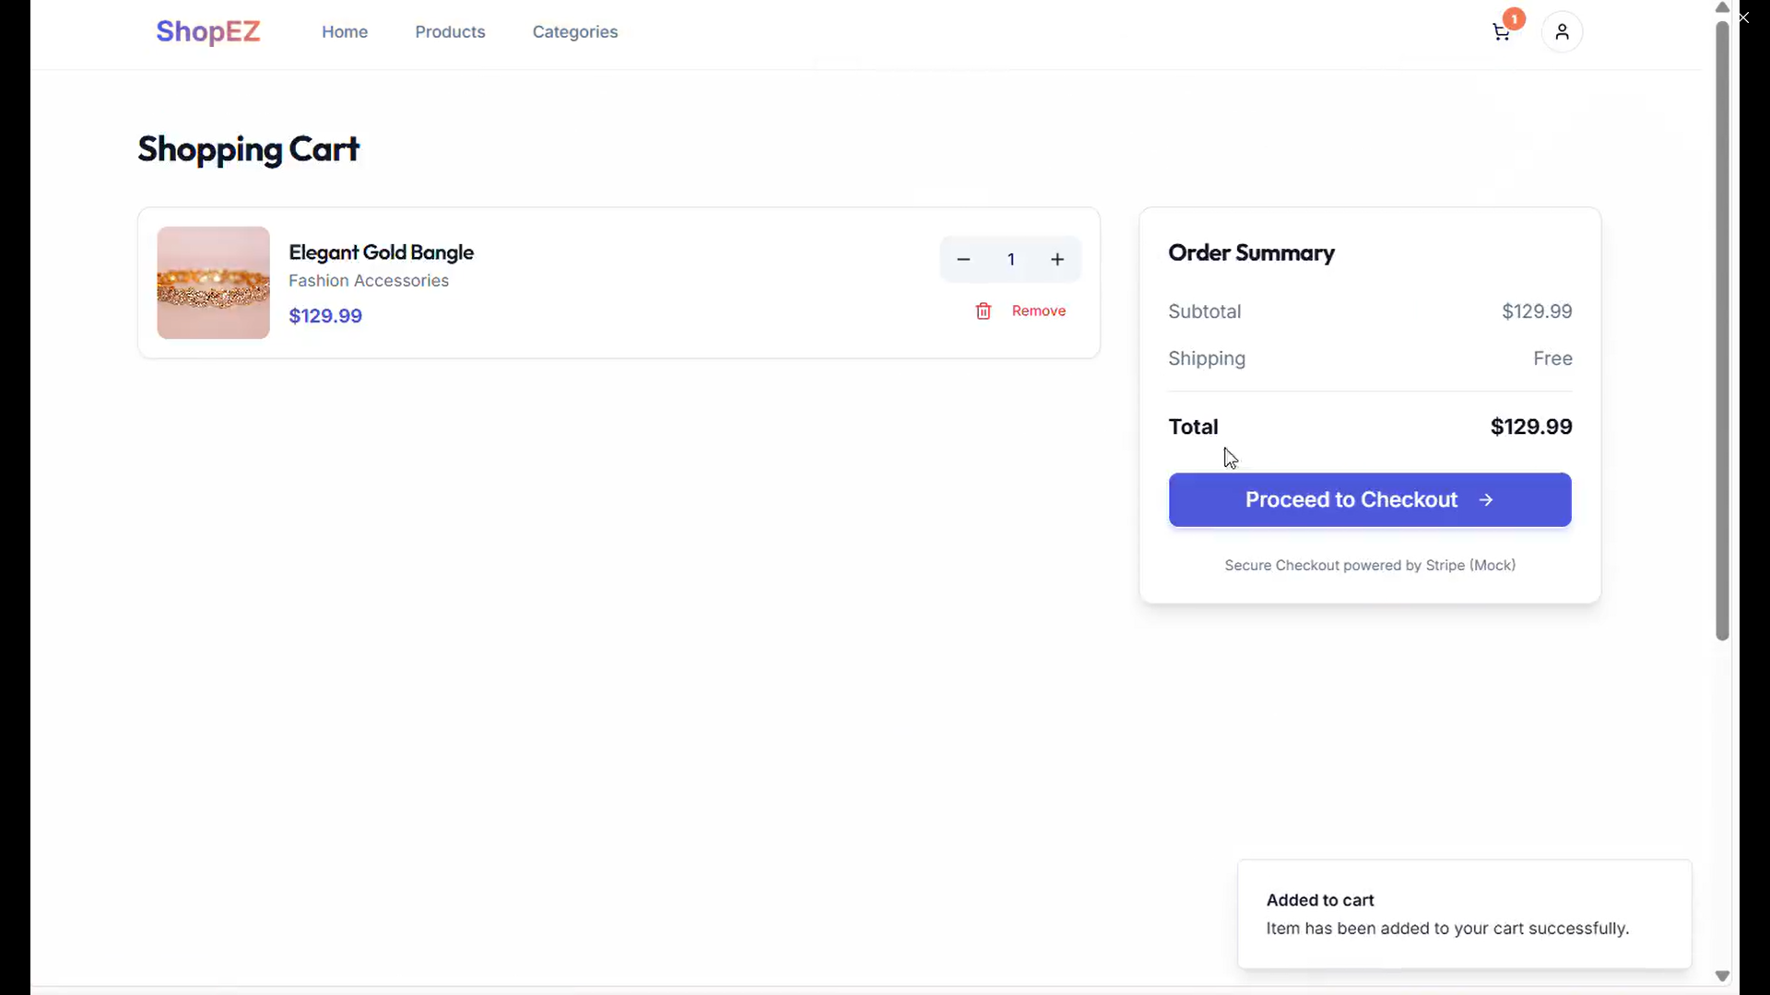
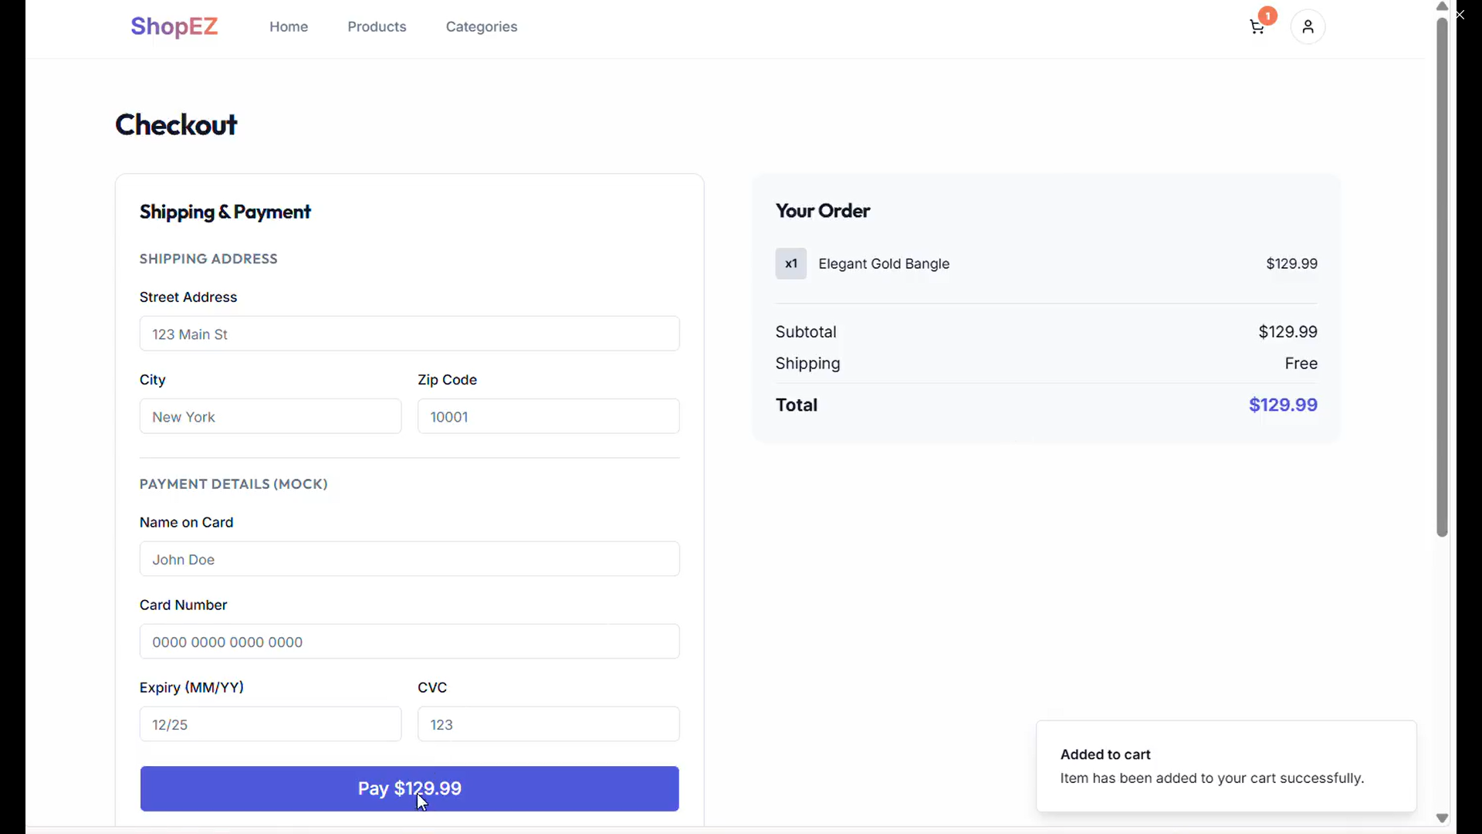
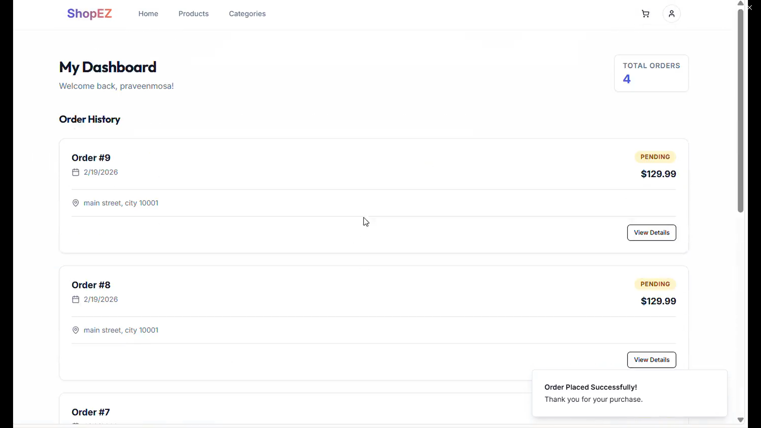

11. Future Enhancements
- Integrate Payment Gateway (Razorpay/Stripe)
- Deploy to Cloud (Render/Vercel)
- Add JWT-based authentication
- Implement inventory tracking
- Advanced product filtering
- Mobile application support

